
Tittle: LOST AND FOUND MANAGEMENT SYSTEM

Course Code : CSE282.4

Course Title : Programming Language II Lab

Department : CSE

Faculty Name : Mr.Md.Ayon Mia

Work Place : SOUTHEAST UNIVERSITY

Assignment Submission Date : 03 June 2026

Submitted By
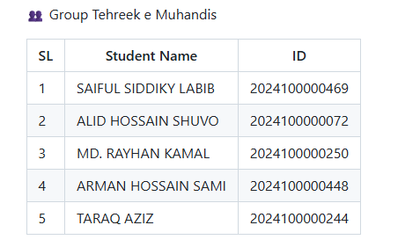

Lost & Found Management System (LFMS).

- INTRODUCTION:

Project Overview:

The Lost & Found Management System (LFMS) is a Java-based

application designed to assist users in reporting lost items, registering

found items, and submitting ownership claims. The system provides

separate functionalities for regular users and administrators to ensure

secure and organized management of lost-and-found records.

Project Objectives:

- Provide a platform for reporting lost items.

- Allow users to register found items.

- Enable ownership claim submission and verification.

- Maintain secure user authentication and authorization.

- Apply Object-Oriented Programming (OOP) principles in

software development.

- SOFTWARE DEVELOPMENT PROCESS:

The project requirements were analyzed and divided into the following modules:

User Module:

- Registration

- Login

- Profile management

Item Management Module:

- Add lost item

- Add found item

- View items

Claim Management Module:

- Submit claim

- Review claim status

Admin Module:

- Approve claims

- Reject claims

- Manage records

3. DEVELOPMENT METHODOLOGY:

An incremental development approach was followed.

Phase 1
- Model Classes

Phase 2
- Service Classes

Phase 3
- Authentication System

Phase 4
- Claim Management

Phase 5
- User Interface Integration(GUI)

Phase 6
- Testing and Bug Fixing

4. SYSTEM DESIGN:

Package Structure:

src
├── model
├── service
├── exception
├── gui
└── main
1.Model Package

Stores system entities.

2.Service Package

Contains business logic.

3.Exception Package

Handles custom exceptions.

4.GUI Package

Contains graphical user interface components.

5.Main Package

Application entry point.

5.SYSTEM ARCHITECTURE:

The application follows a layered architecture:

User Interface Layer
↓
Service Layer
↓
Model Layer
↓
File Storage Layer

6.CLASS DESIGN
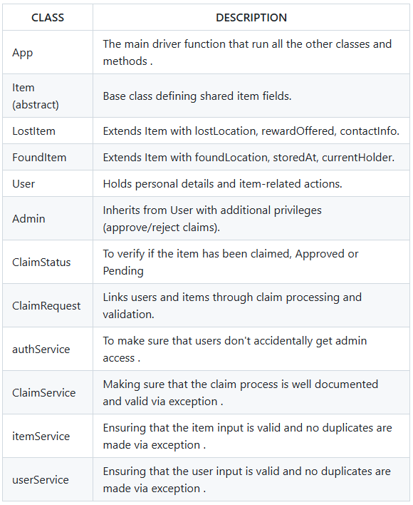

7.CLASS DIAGRAM:
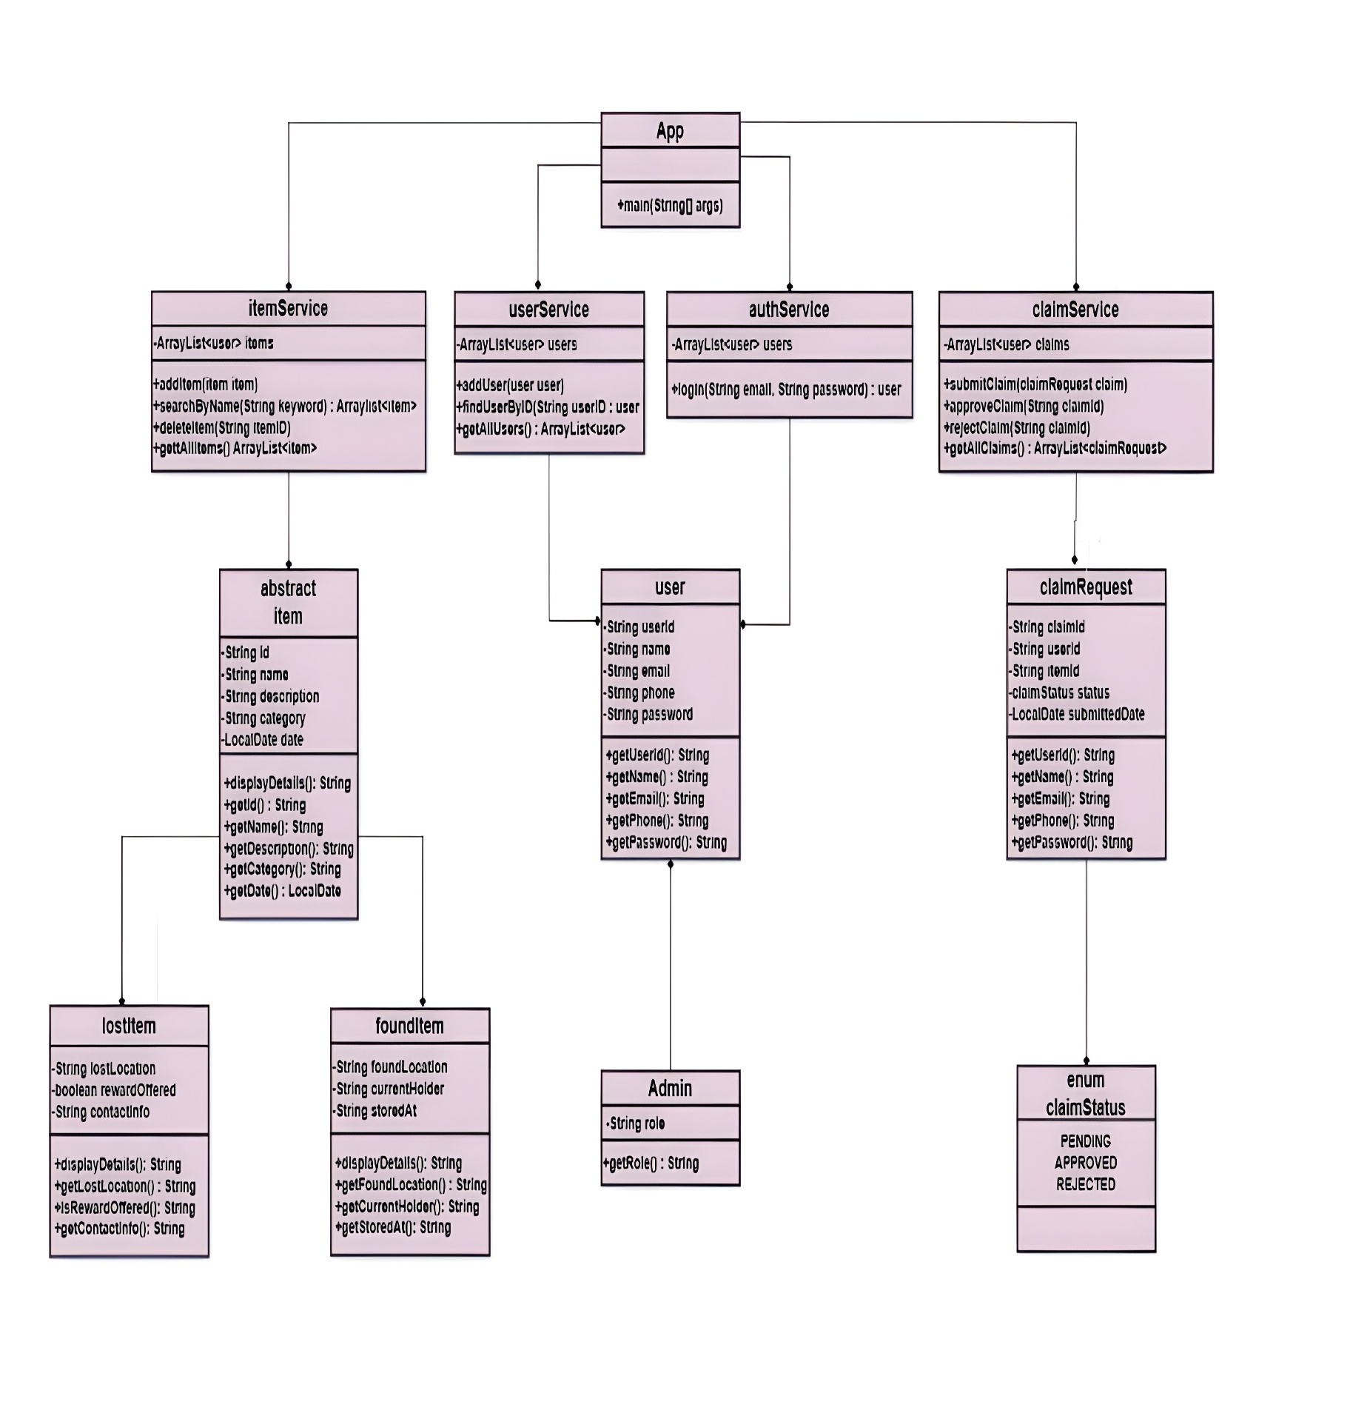
8. OOP Concept Mapping:

Encapsulation:

Encapsulation was achieved by declaring class attributes as private and

providing controlled access through getter and setter methods.

Classes demonstrating encapsulation:

- User

- Admin

- Item

- LostItem

- FoundItem

- ClaimRequest

Inheritance:

User
│
└── Admin
Item
│
├── LostItem
└── FoundItem
Abstraction:

The Item class was designed as an abstract class that defines common item properties

while allowing subclasses to implement specific behavior.

Abstract Class:

- Item

Concrete Implementations:

- LostItem

- FoundItem

Polymorphism:

Polymorphism was implemented through method overriding.

Examples:

- LostItem.displayDetails()

- FoundItem.displayDetails()

Objects of different subclasses can be treated as Item objects while executing their

own specialized implementations.

Exception Handling:

Custom exception handling was integrated into service classes to ensure data integrity

and system reliability.

Service Classes Using Exceptions:

- UserService

- ItemService

- ClaimService

- AuthService

Examples:

- DuplicateUserException

- DuplicateItemException

- UserNotFoundException

- ItemNotFoundException

- ClaimNotFoundException

9.GUI SCREENSHOTS:

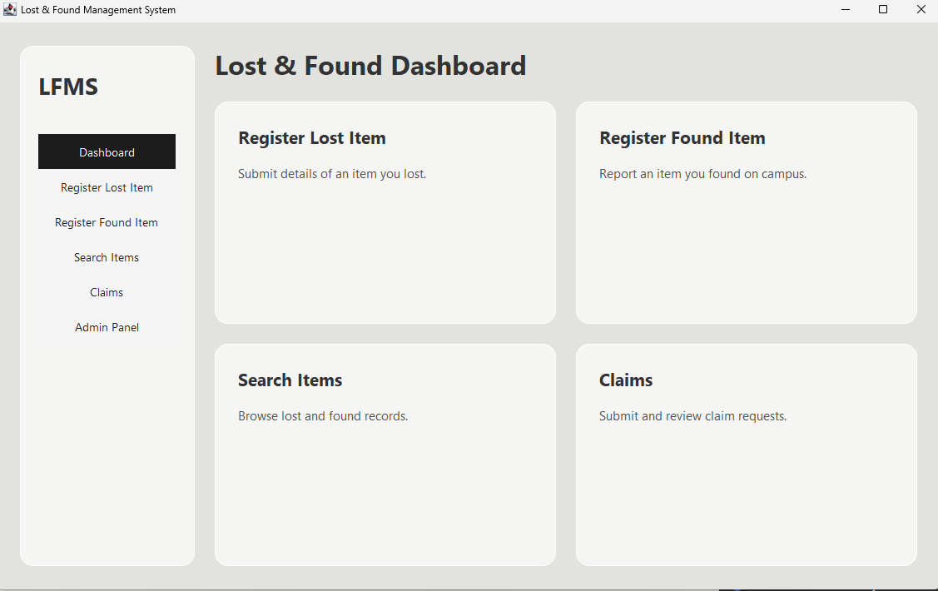
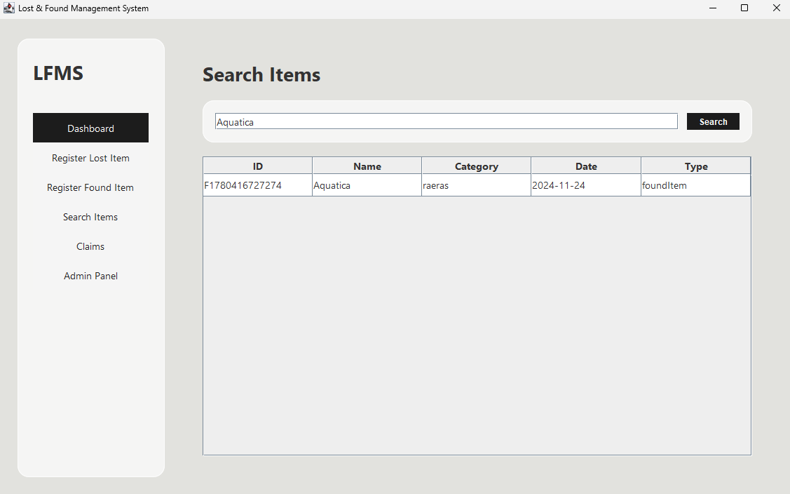

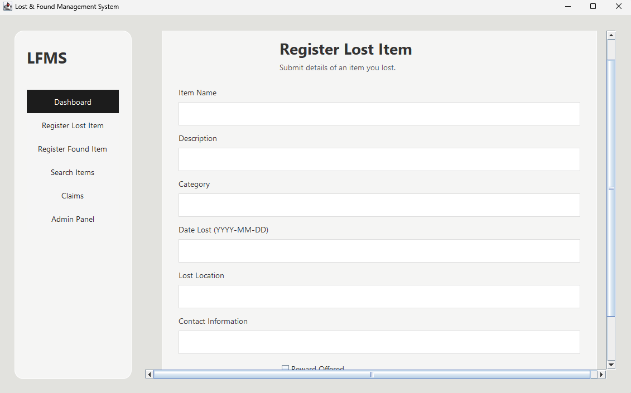
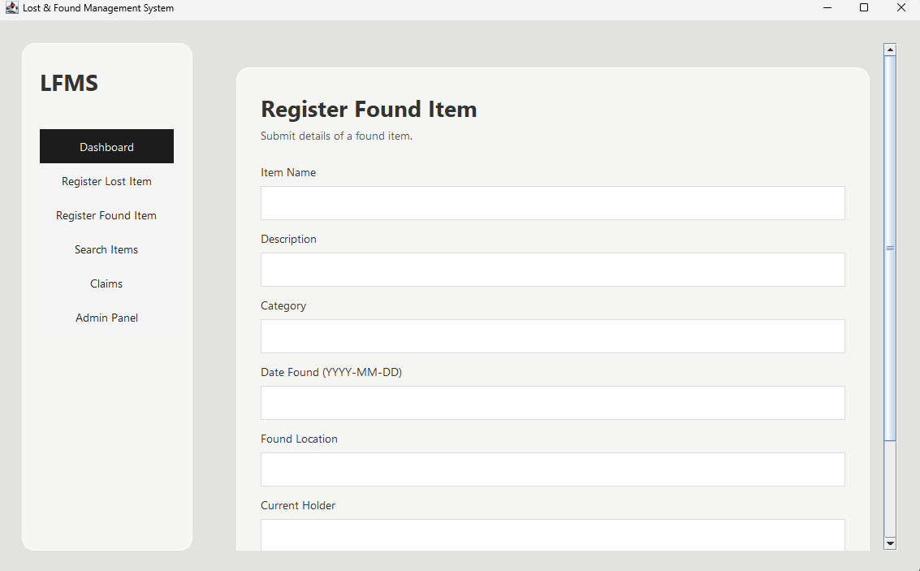

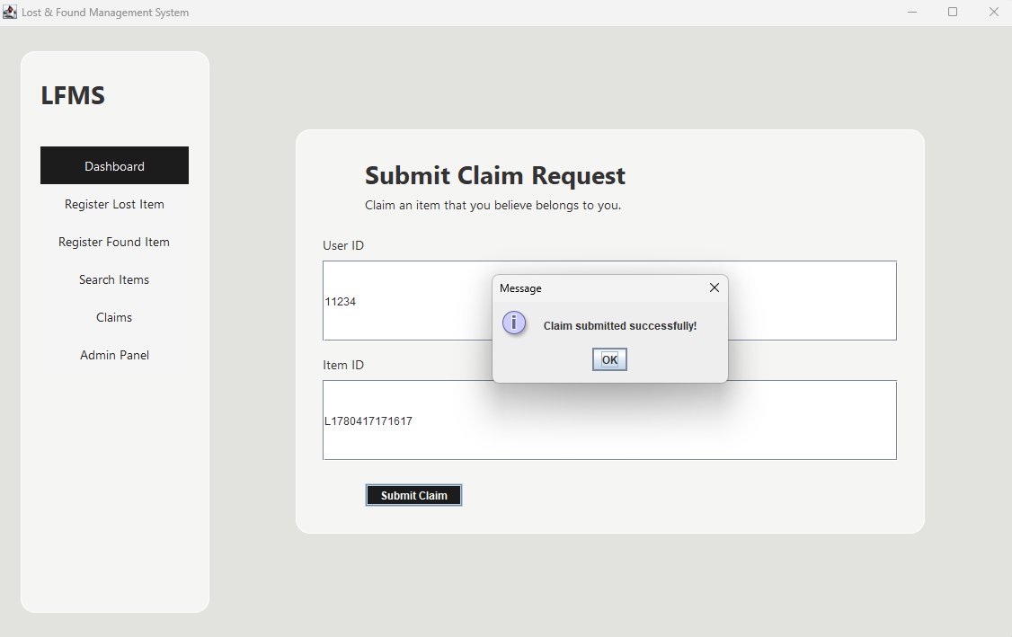
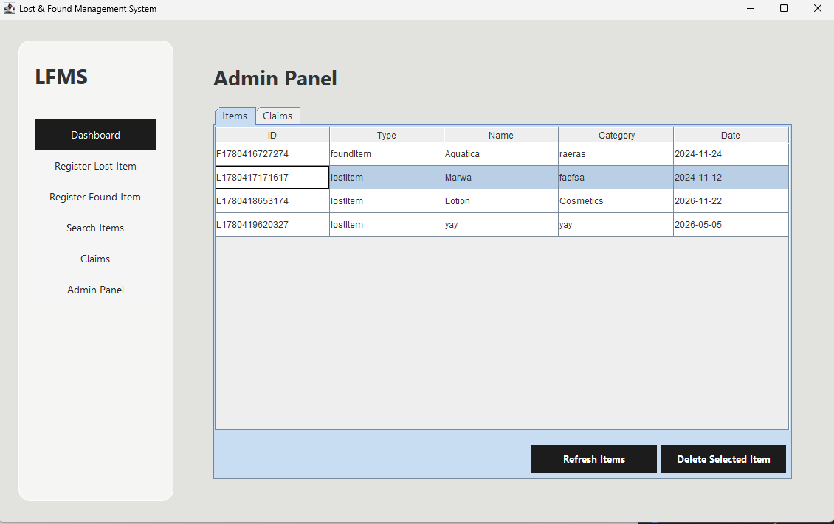

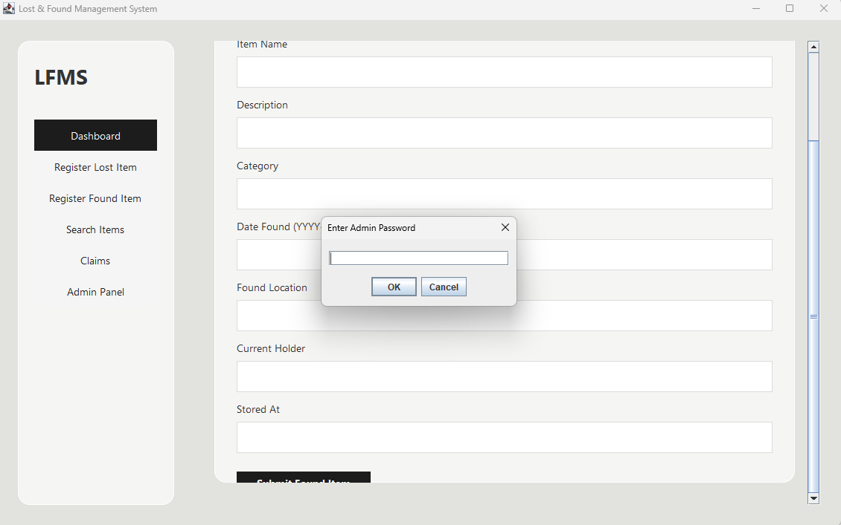
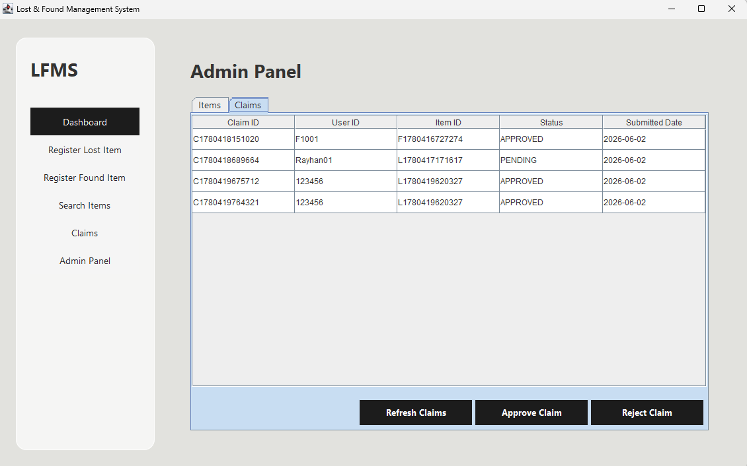

9. REFLECTION ON CHALLENGES FACED:

This project provided practical experience in applying Object-Oriented Programming concepts to a real-world problem. Through collaborative development, the team gained hands-on experience with Git version control, branch management, and software integration.

The project reinforced the importance of proper system design, modular programming, and teamwork. Challenges such as merge conflicts, access control implementation, exception handling, and GUI integration improved our problem-solving abilities and understanding of software engineering practices. The GUI development caused several issues during implementation, especially in terms of layout management and event handling. In addition, designing and implementing the admin panel was a particularly complex task due to the need for strict access control and multiple administrative functions.

Overall, the Lost & Found Management System successfully demonstrated the use of Java, OOP principles, file handling, exception management, GUI development, and collaborative software development techniques.

10. Conclusion:

The Lost & Found Management System was successfully designed and implemented using Java and Object-Oriented Programming principles. The system fulfills its primary objectives of managing lost items, found items, user authentication, and ownership claims. The project also provided valuable experience in software design, implementation, testing, and team-based development using Git and GitHub.

GITHUB REPOSITORY LINK :

https://github.com/LABIBSIDDIKY/LOST-AND-FOUND-MANAGEMENT-SYSTEM

